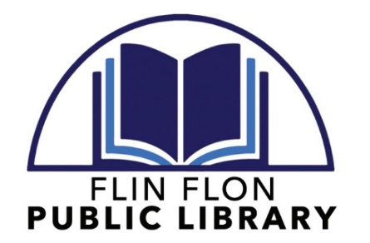

Minutes of the
Flin Flon Library Board of Directors
April 29, 2022 MEETING Minutes
Via Zoom

A regular meeting of the Flin Flon Library Board was held on April 29, 2022 at 12:00 p.m.

QUORUM

Quorum was declared present based on the attendance of the following Board Members:
- Bill Hanson, Chairperson
- Tim Spencer, Secretary/Treasurer
- Judy Pettersen
- Becky Hyska
- Judith MacGowan

Board Members absent:
- Val Dixon
- Kathryn Drapak

Staff present:
- Lisa Slugoski, Library Administrator

PROCEEDINGS

- Chair Hanson called the meeting to order at 12:08 p.m.

- Acceptance of the agenda
MOTION: To accept the agenda as presented (Pettersen); seconded (Spencer); passed unanimously

- Acceptance of the previous meeting minutes
MOTION: To accept the December 18, 2021 meeting minutes as presented (Hyska); seconded (Pettersen); passed unanimously

CORRESPONDENCE

- Letter dated December 10, 2021 from the Kimberley Foundation (re: Pat Morris Community Matter Grant Application – Conclusion Letter)
- Letter dated December 10, 2021 from the Pas Regional Library (re: Shared Funding Cheques for the community of Cranberry Portage)
- Letter dated February 2, 2022 form the Minister of Sport, Culture and Heritage (re: Introduction of new Minister for the Department of Sport, Culture and Heritage)
- Letter dated March 2022 from Manitoba Sport, Culture and Heritage (re: First Nation Communities Read (FNCR) Program)
- Email dated March 9, 2022 from The Winnipeg Foundation (re: Literacy for Life Grant application Decision)
7. Letter dated March 9, 2022 from the Kimberley Foundation (re: Pat Morris Communities Matter Grant application decision)

OLD BUSINESS
- None.

NEW BUSINESS
1. Extending Saturday Hours
-Pettersen brought forth the proposition of continuing Saturday hours until May long weekend.
-Slugoski advised the board of Friday door counts from October through end of December compared to Saturday door counts from the end of January to date.
-It was decided that the library would continue Saturday openings up to, and including, May 14, 2022.

REPORTS

- Library Administrator’s Report (Slugoski)
Slugoski presented the Administrator’s Report.

NEXT MEETING(S)

- June 2022 (Exact date TBD)
ADJOURNMENT
The meeting adjourned at 12:28 pm.
Minutes submitted by Lisa Slugoski, Library Administrator

